***Enabling Pinball FX for DOFLinx***

Assuming you have DOFLinx already running with B2S server and that Pinball FX is installed. If not, the “Start Here – DOFLinx Quicker Guide” may be for you.

1. Copy DOFLinxTrigger.dll from where you unzipped the DOFLinx download to the same folder as PinBallFX-Win64-Shipping.exe

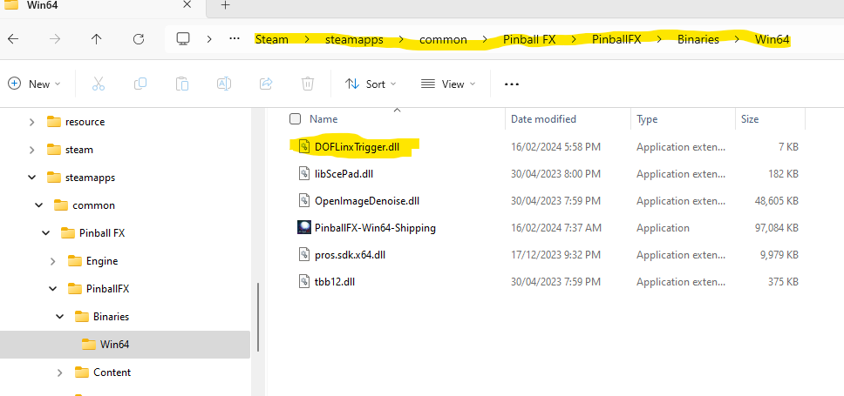

1. Make sure that you’ve got the FX files from the \FX folder in the DOFLinx download zip in a folder where you want them, ie C:\Directoutput\PinballFX\
2. Edit your DOFLinx.INI to
   1. Make Pinball FX activate DOFLinx by adding in the PROCESSES= line PinballFX-Win64-Shipping , So if you wanted MAME and PinballFX to activate DOFLinx you would have PROCESSES=Mame64,PinballFX-Win64-Shipping  
      Note; PinballFX-Win64-Shipping is the process to monitor for, but you still run PinballFX.exe to start PinballFX.
   2. have the PATH_FX= parameter point to the place you put the FX files in step #2 above
   3. have the PATH_FX_B2S= parameter point to the place you have / will place your set of Pinball FX active back glasses  
        
      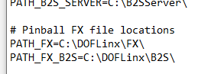
3. Get the complete set of active back glasses from <https://drive.google.com/drive/folders/1AjJ8EQo3AkmG2mw7w0fLzF9HcOjFoUZH?usp=sharing> and place them in the folder you just setup in 3c above.  
     
   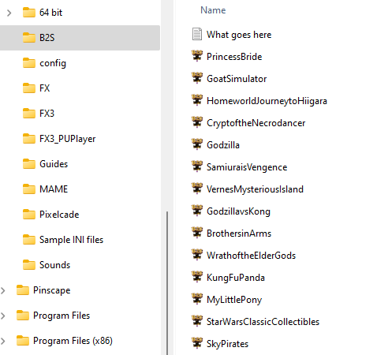
4. Start Pinball FX
5. Go to Settings | Cabinet
6. Activate cabinet mode if it is not already
7. Go to the DOFLinx tab, enable it

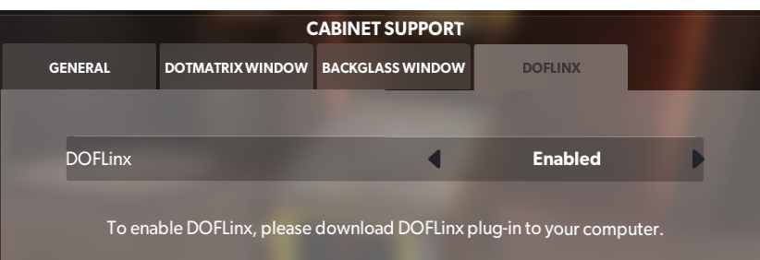

1. Start it all up and have fun.

Notes

1. A couple of people have reported that PinballFX will not “talk” to DOFLinx if DOFLinx is set to “run as administrator”. Check this if you have a problem.